Adapting to Testing Mindset
Started with following root directories where the files or packages are located using the below command
cd /app/lab: this change directory command navigates the terminal to the /app/lab folder. This is crucial because “npm install” must run withing the project’s root directory (where package.json file is located) to function correctly.
Npm install: reads the package.json and package-lock.json files in the current directory and downloads all the listed dependencies into node modules folder. In simple term it sets up an environment to run or build a project.
bash start.sh: executes start.sh script using bash shell. It contains custom logic to start the application.
Lab Walkthrough of Microsoft Fundamentals and Testing Course
After installing the dependencies, I used the chrome browser to visualize the website running at https://localhost:3000/
Adopting the Testing Mindset
After login in as an admin using the admin credentials given, I checked the checkout page and included letters, short numbers, long number, special character in the postal/zip code section, and founded the bug that it accepted the checkout. Used format:
- letters (testing)
- too short / too long (12, 1234567890)
- symbols (@#%)
- empty

Learned Bug Report Writing Techniques in Notepad
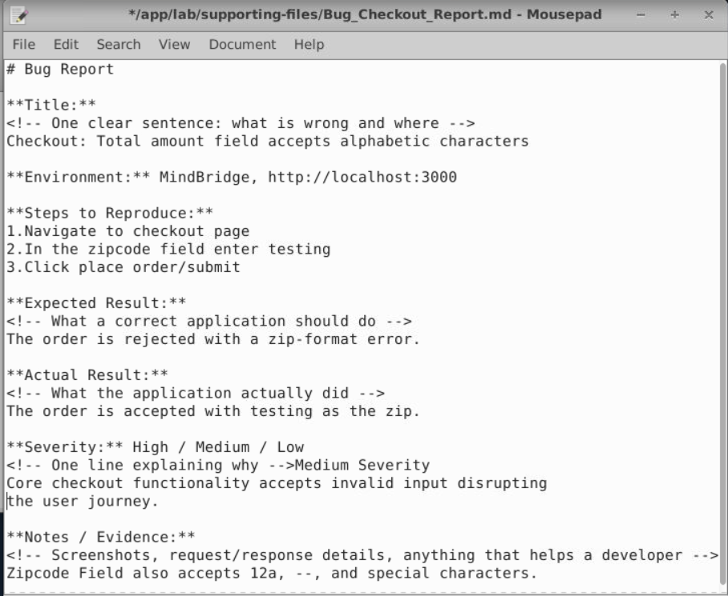
Roles of SDLC: QA (Quality Assurance), QC (Quality Control), UAT (User Acceptance Testing)
Quality Assurance refers to architecture of the test cases,
QC checks the functionality of the test cases designed by the QA engineers
User Acceptance Testing is the final phase of testing done by stakeholders or Customer Representatives.
The 7 Fundamental Testing Principles
- Testing Shows the Presence of Defects
- Exhausting Testing is impossible
- Early Testing
- Defect Clustering
- Pesticide Paradox
- Testing is Context-Dependent
- Absence of Errors fallacy

Putting the Principles into Practice
- Create a risk-based test plan
- Maintain a defect-trend dashboard
- Use exploratory testing
- Iterate test data

Identifying QC vs. QA in Practice
Follows RACI matrix (Responsible, Accountable, Consulted, Informed)
QA task is to set up the rules, define the process and ensure process adherence.
QC is about finding defects in the products and test the functionality of the products.

Module_2 Web Architecture Matters to QA
QA is responsible to handle not only the front-end testing but also the logic, Front-end bugs doesn’t impact much as compare to back-end logic bug, the back-end logic -if failed can cause a huge problem to the system and could compromise the confidential data of user and system.
Imagine a banking app. If you only test the UI, you might confirm that the "Transfer" button works. But what if the application-layer business logic calculates the final balance incorrectly? Or what if a security flaw in an API allows unauthorized access to account data? These are the kinds of high-impact bugs that UI-only testing almost always misses. Relying solely on front-end testing creates significant risks:
- Business Logic Failures: Incorrect calculations, flawed workflows, and wrong data processing can go undetected.
- Data Integrity Issues: The application might display correct information while silently corrupting data written to the database.
- Security Vulnerabilities: Critical security flaws often exist in the hidden Application Programming Interface (API) layer, not in the visible interface.
- Wasted Effort: A developer might spend hours fixing what appears to be a "UI bug," only to find the root cause is a back-end issue.
Three Layer of Web Application
- Presentation Layer: what you interact with (UI interaction)
- Application Layer: Contains business logic, and processes user’s action
- Data Layer: Stores and retrieves
Mapping QA Activities to Web Layers
Testing the Presentation Layer (UI)
- Functional Testing: This verifies that interactive elements work correctly. Can you click on buttons and links? Can you fill out and submit forms? If you add an item to a cart, does the cart icon update?
- Cross-Browser and Responsiveness Testing: Does the application look and function correctly on different web browsers (like Chrome, Firefox, and Safari)? Does the layout adapt properly to different screen sizes, such as a desktop monitor, a tablet, and a mobile phone? This ensures a consistent experience for all users.
- Usability Testing: Is the application intuitive and easy to navigate? A usability test focuses on the user's experience. Even if every button works perfectly, the application fails if users can't figure out how to complete their tasks.
- Accessibility Testing (a11y): Can people with disabilities use the application? This involves checking for things like proper color contrast, keyboard navigation, screen reader compatibility, and descriptive alt text for images.
Testing the Application Layer (back-end/business logic)
Key activities for API testing include:
- API Functional Testing: Do the API endpoints work as expected? If you send a request to get a user's profile, does the API return the correct data in the correct format? This type of testing checks the request and response payloads for accuracy.
- Security Testing: Can a user access data they aren't authorized to see? API security testing involves trying to bypass authentication, testing for data leaks in responses, and ensuring sensitive data is handled securely.
- Performance Testing: How does the API behave under heavy load? Performance tests might simulate hundreds or thousands of users making requests simultaneously to see whether the API slows down or crashes.
Testing the Data Layer (Database)
Key activities for database testing include:

- Blueprint and Data Type Validation: Do the database table structures match the design? If a field is supposed to store a number, does the database prevent you from saving text in it? This testing verifies the database's fundamental architecture.
- Data Integrity Testing: This is the most critical part of database testing. When a record is created, updated, or deleted, do the changes reflect correctly in the database? For example, if a user updates their shipping address, does the addresses table show the new information, and is the old information correctly archived or removed? This also includes checking for orphaned records or incorrect relationships between tables.

- Data Migration Testing: If you are moving from an old system to a new one, was all the data transferred correctly? This involves writing scripts to compare the data in the source and destination databases to ensure nothing was lost or corrupted during the migration.

Creating a Traceability Matrix for Full Coverage
How do you ensure you've tested all layers for every feature? A traceability matrix is a simple but powerful tool for this. It's a table that maps user requirements to the specific test cases designed to validate them. This ensures that no requirement is missed and that you have test coverage across the entire application stack.
Imagine a requirement: "As a user, I can update my profile information." Here's what a simple traceability matrix might look like:
Requirement | UI Test Case ID | API Test Case ID | Database Test Case ID
As a user, I can update my profile information. | TC-UI-01: Verify that the "Save" button on the profile page becomes clickable after a field is edited. | TC-API-05: Send a PUT request to /api/users/{id} with a valid payload and verify a 200 value and verify an OK response. | TC-DB-09: After a successful API call, query the users table to confirm that the updated_at and user information fields are correct.
This matrix makes it easy to see at a glance that the requirement is being tested at every layer, ensuring complete coverage.
Tracing Data Flow Using Browser Developer Tools
Learning about how to use developer tools to trace user’s selection from the Presentation Layer to the Application Layer and back again.

Inspect Web Layers and Map Testing
User Action, “Presentation Layer”, “Application Layer”, “Expected Status Code”, “Data Layer"

Navigated to Login Page and inspected towards "Sign in" button, the elements
tab highlights the button's HTML. Noted that the <button type='submit'>, class
attribute is inline-flex items-center px-4 py-2 rounded-md text-white transition-colors focus-visible: outline focus-visible: outline-2 focus-visible: outline-offset-2 disabled: opacity-60 disabled: cursor-not-allowed bg-indigo-600 hover:bg-indigo-700 focus-visible: outline-indigo-600 w-full justify-center>
And switched back to Network tab (filter Fetch/XHR)
Catalogue load result analyzed using Network tab from web browser inspect method.
{Request URL
http://localhost:3000/api/courses?page=1&pageSize=20
Request Method
GET
Status Code
200 OK
Courses were displayed/shown successfully}
View a single course:> Selected the single course
{Request URL
http://localhost:3000/api/courses/01M6WKWS9ERX0K9NP9AFJYE1AY
Request Method
GET
Status Code
200 OK
Reads rows from the courses table}
Filter by level:> Filter level work well, shows courses according to levels
{Request URL
http://localhost:3000/api/courses?page=1&pageSize=20&level=intermediate
Request Method
GET
Status Code
200 OK
}
Search by title:> Successfully searched using title
{Request URL
http://localhost:3000/api/courses?page=1&pageSize=20&search=software+testing
Request Method
GET
Status Code
200 OK}
Add a course to the cart:> Added courses to the cart successfully
{Request URL
http://localhost:3000/api/cart/items
Request Method
POST
Status Code
201 Created
Cart number increases everytime course is added to the card from course list.}
Submit a payment with a special character:> Error recorded as "Order not complete, and server crashes out"
{Request URL
http://localhost:3000/api/checkout
Request Method
POST
Status Code
500 Internal Server Error
}
Above testing is done using a Lab for Map testing for Web Browser provided by the Course of Software Testing Fundamentals and Methodologies.

